

CATHI

**C**aregiver’s **A**nswers, **T**opics, and **H**elpful **I**nformation

In an endeavor to continually assist caregivers in their search for pertinent information regarding eldercare, our Information and Referral Specialists address topics most frequently asked questions via **C**aregiver’s **A**nswers, **T**opics, and **H**elpful **I**nformation (**CATHI**). Additionally, caregivers are invited to e-mail individual questions to **caregiver2@senior-resources-guilford.org** and an Information and Referral Specialist will reply.

Dear CATHI, **how can I celebrate the holidays with everything I’m dealing with?**

With the holidays quickly approaching, caregivers may ask themselves this question. It’s normal for caregivers to respond this way, especially when dealing with feelings of grief, stress, depression, exhaustion, and guilt. While it may be tempting to shut the world out, understand that you are not alone and there are some things you can do to honor your situation while also staying connected to your loved ones during the holidays.

Caregivers often must adapt their traditional role during the holidays. Let your family know that you will need to do things differently this year. Do not be afraid to change what is no longer comfortable, convenient, or enjoyable for you or your loved one. This may mean allowing other family members to host more time-intensive activities. You may need to lessen the amount of time away from home to match the comfort level of your care recipient. You may also have to choose events based on which are the least exhausting, most enjoyable, and accessible to your care recipient. There is no need to apologize or feel guilty – your circumstances have changed, and you are adapting to “the new normal”.

In the past, your role may have been to prepare a large dinner, host family members, or decorate your home inside and outside. Give yourself permission to do what is reasonably manageable considering the energy and time you must put into caregiving. Allow yourself a break from large expectations and find a compromise. Maybe this year you only decorate the living room, or you host a potluck with just a few family members. When decorating, keep rooms well-lit and avoid flashing lights or candles, as these may disrupt or pose a danger to those with dementia.

Often families must make changes to their traditions to include the care recipient. Your family may have enjoyed ice skating the weekend of Christmas, but your care recipient experiences mobility issues. Offer ideas to your family that accommodate your care recipient, such as gathering for a holiday movie night or spending time outside around a campfire, roasting marshmallows.

Don’t expect your care recipient to be able to adapt to all situations. You may need to designate a quiet space for them. Many people with dementia find multiple conversations and background noise disturbing. To avoid this anxiety, this person may benefit from time in a quieter room with less stimulus where family members can take turns visiting them.

Keep a predictable routine for you and your care recipient. Maintaining a bedtime, waking, meals, and activities for your care recipient is critical. Share your schedule with your family in advance so they know when you and your care recipient are available. Respect your need for routine and care as well. Getting enough sleep, eating well-balanced meals, and managing your energy will ensure that you and your care recipient are able to enjoy special days with your family.

Provide your family gift suggestions for you and your care recipient. Puzzles, comfy clothing, subscriptions to streaming services or favorite movies are all great ideas for your care recipient. Remind the family that dangerous tools, complicated electronics, and challenging board games may not be the best option for your care recipient. Consider asking for time for yourself, assistance with tasks around the home, or respite as a gift for yourself. Gift certificates or gift cards for relaxing activities are also a great suggestion.

Remember there is no right or wrong way to celebrate the holidays. Maintaining the health and well-being of both you and your care recipient is far more important this year. Be gentle with yourself, and your loved ones, and take time to set expectations in advance.

*The information in this article was adapted from “Holidays” by the Alzheimer’s Association, by Family Caregivers Online “Caregiving and the* Holidays*: From Stress to Success!” by Family Caregiver Alliance.*

|  |
| --- |
| ***Note: This is for informational purposes only.*** |

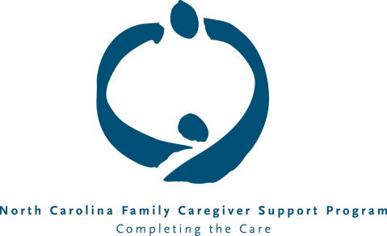For referrals to community organizations in Guilford County that assist older adults and caregivers, contact Senior Resources of Guilford’s SeniorLine at (336) 333-6981 in Greensboro and Guilford Co., in High Point/Jamestown (336) 884-6981 or the Caregiver Support Specialist, at (336) 373-4816 or (336) 883-3586 in High Point.